FORM 1  THE PATENT ACT 1970  (39 OF 1970) &  The Patents Rules, 2003  APPLICATION FOR GRANT OF PATENT  [See sections 7,54 & 135 and rule 20(1)] | (FOR OFFICE USE ONLY)  Application No.: ...........................  Filing Date: ...................................  Amount of Fee Paid: ...................  CBR No.: ......................................  Signature: .....................................

1. APPLICANT(S):

Sr. No. | Name | Nationality | Address | Country | State
1 | Mrs. Gavini Venkata Leela Kumari | India | Assistant Professor, Department of CSE (Artificial Intelligence and Machine Learning),  Bapatla Engineering College, Bapatla 522102, Andhra Pradesh, India | India | Andhra Pradesh
2 | Mr. Palaparthi Venkata  Naga Srinivas | India | Assistant Professor,  Department of CSE (Artificial Intelligence and Machine Learning), Bapatla Engineering College, Bapatla 522102, Andhra Pradesh, India | India | Andhra Pradesh
3 | Gaddam Venu | India | Department of CSE (Artificial Intelligence and Machine Learning), Bapatla Engineering College, Bapatla 522102, Andhra Pradesh, India | India | Andhra Pradesh
4 | Jeevan Devandla | India | Department of CSE (Artificial Intelligence and Machine Learning), Bapatla Engineering College, Bapatla 522102, Andhra Pradesh, India | India | Andhra Pradesh
5 | Gulivindala Sri Lakshmi Sarojini | India | Department of CSE (Artificial Intelligence and Machine Learning), Bapatla Engineering College, Bapatla 522102, Andhra Pradesh, India | India | Andhra  Pradesh
6 | Doppalapudi Sri Sai Teja | India | Department of CSE (Artificial Intelligence and Machine Learning), Bapatla Engineering College, Bapatla 522102, Andhra Pradesh, India | India | Andhra  Pradesh
7 | Mudraboina Durgarao | India | Department of CSE (Artificial Intelligence and Machine Learning), Bapatla Engineering College, Bapatla 522102, Andhra Pradesh, India | India | Andhra  Pradesh
8 | Bapatla Engineering College | India | Bapatla Engineering College, Bapatla 522102, Andhra Pradesh, India | India | Andhra  Pradesh

2. INVENTOR(S):
Sr. No. | Name | Nationality | Address | Country | State
1 | Mrs. Gavini Venkata Leela Kumari | India | Assistant Professor, Department of CSE (Artificial Intelligence and Machine Learning),  Bapatla Engineering College, Bapatla 522102, Andhra Pradesh, India | India | Andhra Pradesh
2 | Mr. Palaparthi Venkata  Naga Srinivas | India | Assistant Professor, Department of CSE (Artificial Intelligence and Machine Learning),  Bapatla Engineering College, Bapatla 522102, Andhra Pradesh, India | India | Andhra Pradesh
3 | Gaddam Venu | India | Final Year B. Tech student, Department of CSE (Artificial Intelligence and Machine Learning),  Bapatla Engineering College, Bapatla 522102, Andhra Pradesh, India | India | Andhra Pradesh
4 | Jeevan Devandla | India | Final Year B. Tech student, Department of CSE (Artificial Intelligence and Machine Learning),  Bapatla Engineering College, Bapatla 522102, Andhra Pradesh, India | India | Andhra Pradesh
5 | Gulivindala Sri Lakshmi Sarojini | India | Final Year B. Tech student, Department of CSE (Artificial Intelligence and Machine Learning),  Bapatla Engineering College, Bapatla 522102, Andhra Pradesh, India | India | Andhra  Pradesh
6 | Doppalapudi Sri Sai Teja | India | Final Year B. Tech student, Department of CSE (Artificial Intelligence and Machine Learning),  Bapatla Engineering College, Bapatla 522102, Andhra Pradesh, India | India | Andhra  Pradesh
7 | Mudraboina Durgarao | India | Final Year B. Tech student, Department of CSE (Artificial Intelligence and Machine Learning),  Bapatla Engineering College, Bapatla 522102, Andhra Pradesh, India | India | Andhra  Pradesh

3. TITLE OF THE INVENTION:
Autonomous Multi-Agent Hybrid Healthcare Intelligence System
4. ADDRESS FOR CORRESPONDENCE OF APPLICANT/
AUTHORISED PATENT AGENT IN INDIA:

Mrs. Gavini Venkata Leela Kumari, Assistant Professor, Department of CSE (Artificial Intelligence and Machine Learning), Bapatla Engineering College, Bapatla 522102, Andhra Pradesh, India
Phone: 9492736258
Email: gavinileela@gmail.com
Telephone No.: 9492736258
Fax No.:
Mobile No: 9492736258
E-mail: gavinileela@gmail.com

5. PRIORITY PARTICULARS OF THE APPLICATION(S) FILED IN CONVENTION COUNTRY:
Sr.No. | Country | Application Number | Filing Date | Name of the Applicant | Title of the Invention

6. PARTICULARS FOR FILING PATENT COOPERATION TREATY (PCT) NATIONAL PHASE APPLICATION:

International Application Number | International Filing Date as Allotted by the Receiving Office

7. PARTICULARS FOR FILING DIVISIONAL APPLICATION

Original (first) Application Number | Date of Filing of Original (first) Application

8. PARTICULARS FOR FILING PATENT OF ADDITION:

Main Application / Patent Number: | Date of Filing of Main Application

9. DECLARATIONS:

(i) Declaration by the inventor(s)

We, Mrs. Gavini Venkata Leela Kumari, Mr. Palaparthi Venkata Naga Srinivas, Gaddam Venu, Jeevan Devandla, Gulivindala Sri Lakshmi Sarojini, Doppalapudi Sri Sai Teja and Mudraboina Durgarao, Bapatla Engineering College are the true & first inventors for this invention and declare that the applicants herein are our assignee or legal representatives.

(a) Date: 09-04-2026
(b) Signature(s) of the inventor(s):

c) Name(s):
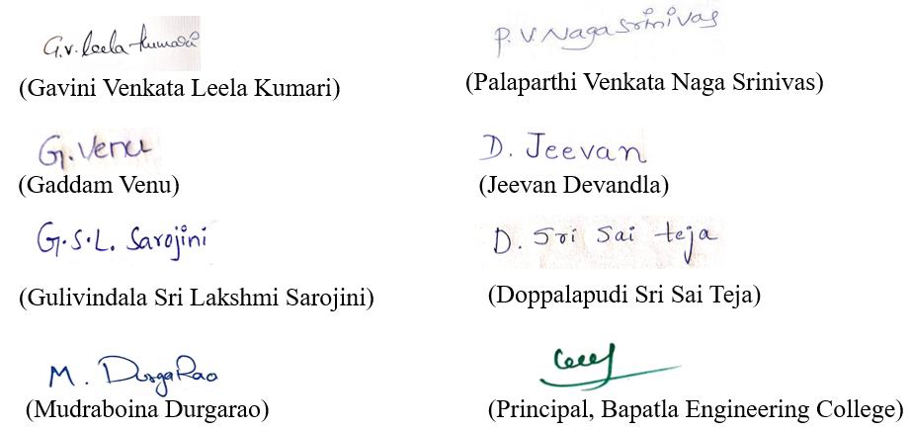

(ii) Declaration by the applicant(s) in the convention country
We, the applicant(s) in the convention country declare that the applicant(s) herein is/are my/our assignee or legal representative.

(a) Date: 25-06-2023
(b) Signature(s) :


(c) Name(s) of the signatory: Mrs. Gavini Venkata Leela Kumari, Mr. Palaparthi Venkata Naga Srinivas, Gaddam Venu, Jeevan Devandla, Gulivindala Sri Lakshmi Sarojini, Doppalapudi Sri Sai Teja and Mudraboina Durgarao, Bapatla Engineering College.

(iii) Declaration by the applicant(s)

- The Complete specification relating to the invention is filed with this application. (√)
- I am/ we are, in the possession of the above-mentioned invention. (√)
- There is no lawful ground of objection to the grant of the Patent to me/us. (√)

10. FOLLOWING ARE THE ATTACHMENTS WITH THE APPLICATION:
Sr. | Document Description | File Name

I/We hereby declare that to the best of my/our knowledge, information, and belief the fact and matters stated herein are correct and I/We request that a patent may be granted to me/us for the said invention.

Dated this (Final Payment Date): 09-04-2026
Signature:
Name:


To The Controller of Patents
The Patent Office at CHENNAI

This form is electronically generated.

